DOCUMENTATION

ROCK IDENTIFICATION USING DEEP cnn(#CONVOLUTIONAL NEURAL NETWORK)

**INTRODUCTION**

* **OVERVIEW**

Convolutional neural networks are used to train and identify rock thin sections. There are three innovations in this method. Firstly the convolutional neural network is used in the field of geological experiment testing and it can automatically identify and classify the rock thin sections. Secondly the original image of rock thin sections are sliced and segmented, so that the convolutional neural network could learn more details of the rock mineral texture without damaging the original resolution of the image. Thirdly using other image enhancement techniques, such as random flipping and standardization, can expand the sample data set and enhance the robustness of the model. Finally the training model achieves the desired results.

* **PURPOSE**

**Convolution neural network (CNN**) is an important deep learning architecture. It can extract the image features automatically and has a high classify accuracy. A Convolutional neural network (CNN) is a neural network that has one or more convolutional layers and are used mainly for image processing, classification, segmentation and also for other auto correlated data. A convolution is essentially sliding a filter over the input. **CNN** is used in computer vision, mainly in face recognition, scene labelling, image classification, action recognition, human pose estimation and document analysis. This layer ensures the spatial relationship between pixels by learning image features using small squares of input data. This is the most important layer that contains a set of filters whose parameters need to be learned. Important information regarding the nature of rocks is communicated through concise, accurate descriptions. This information allows the geologist to identify the rock, and, in the process, to learn about its history and the geological environment in which it was formed.

**LITERATURE SURVEY**

* **EXISTING PROBLEM**

Rocks are a fundamental component of Earth. The automatic identification of rock type in the field would aid geological surveying, education, and automatic mapping. It is a basic part of geological surveying and research, and mineral resources exploration. The automatic identification of rock type in the field would aid geological surveying, education, and automatic mapping. Working conditions in the field generally limit identification to visual methods, including using a magnifying glass for fine-grained rocks. Visual inspection assesses properties such as color, composition, grain size, and structure. The attributes of rocks reflect their mineral and chemical composition, formation environment, and genesis. The color of rock reflects its chemical composition. But these analysis is time taken process to identify the rocks. Its application here has effectively identified rock types from images captured in the field. This paper proposes an accurate approach for identifying rock types in the field based on image analysis using deep convolutional neural networks.

* **PROPOSED SOLUTION**

Deep learning is receiving significant research attention for pattern recognition and machine learning. Its application here has effectively identified rock types from images captured in the field. This paper proposes an accurate approach for identifying rock types in the field based on image analysis using deep convolutional neural networks. The results show that the proposed approach based on deep learning represents an improvement in intelligent rock-type identification and solves several difficulties facing the automated identification of rock types in the field. Who are experienced in the field of geological they can identify the rocks easily. But who are new to the field, it can help to identify the type of rock.

**THEORETICAL ANALYSIS**

* **BLOCK DIAGRAM**

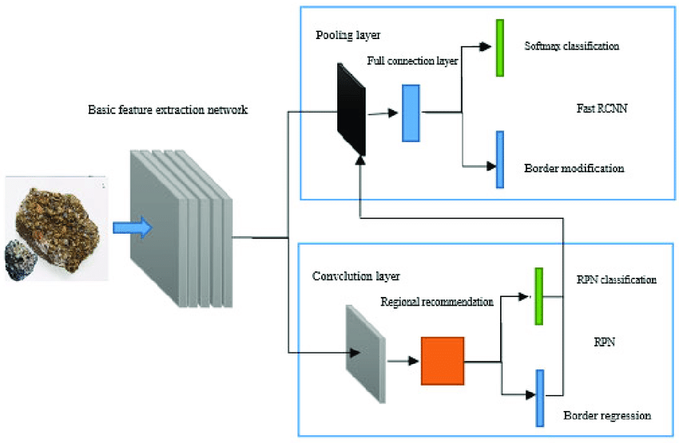

**HARDWARE / SOFTWARE DESIGNING**

* The hardware description requires an enable signal and thirty six pixel values. Each convolution has 9 input pixels in a 3x3 matrix.
* For each 36 input pixels, it outputs one numeric value and a valid signal (v). Within the architecture, each stage of the CNN process is a separate component.
* The pooling stage requires four input values, so in order to acquire these four values a state machine keeps track of each 3x3 input convolution and ReLU.
* After all four pooling input registers are filled, the pooling stage is able to commence.
* The valid signal is turned on after the pooling stage is done.
* This signal is used in the hardware verification to let the FPGA know when to write the final output value and when to re-enable this hardware architecture again.



**DATA COLLECTION**

**Data collection** is the process of **gathering** and measuring information from countless different sources. In order to use the **data** we collect to develop practical artificial **intelligence** (AI) and **machine learning** solutions, it must be **collected** and stored in a way that makes sense for the business problem at hand.

The given dataset is related to “**ROCKS”.** It was taken from various websites.

**DATA PREPROCESSING**

We use **Keras’ ImageDataGenerator class** to perform data augmentation. i.e, we are using some kind of parameters to process our collected data. The word “**augment**” means to make something “**greater**” or “**increase**” something.

* **Import the ImageDataGenerator Library:**

The **ImageDataGenerator** accepts the **original data**, randomly transforms it, and returns only **the new, transformed data.**

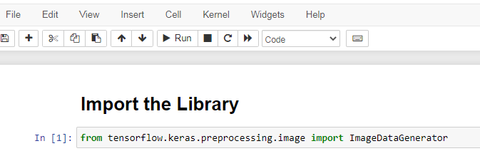

* **Configure ImageDataGenerator Class:**

The **ImageDataGenerator** transforms each image in the batch by a series of **random translations**, these translations are **based on the arguments.**

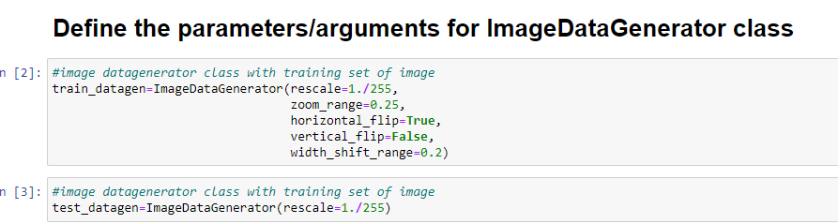

* **Apply ImageDataGenerator functionality to**

**trainset and testset :**

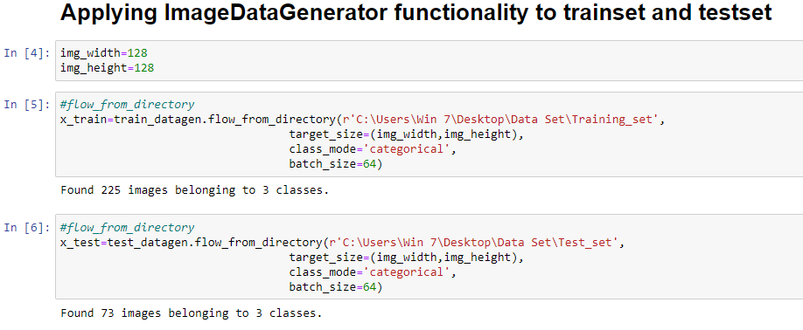

**MODEL BUILDING**

**Steps to Build a Deep Learning Model**

1. Defining the model architecture

2. Configure the learning process

3. Train The Model

4. Save the Model

5. Predictions

* **Importing the Model Building Library:**

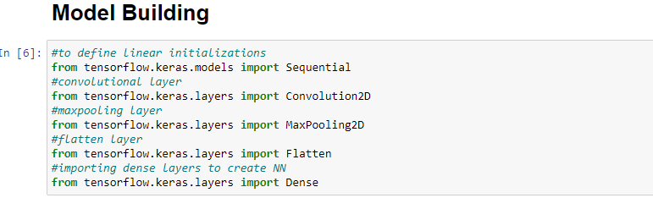

* **Initializing the model**

Keras has 2 ways to define a neural network:

* Sequential
* Function API

The Sequential class is used to define a linear initializations of network layers which then, collectively, constitute a model. In our example below, we will use the Sequential constructor to create a model, which will then have layers added to it using the add() method.



* **Adding CNN layers**

**We will be adding three layers for CNN**

* Convolution layer
* Pooling layer
* Flattening layer



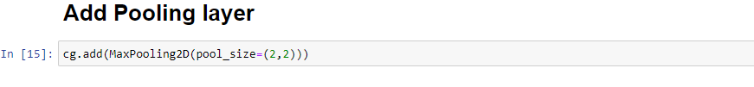

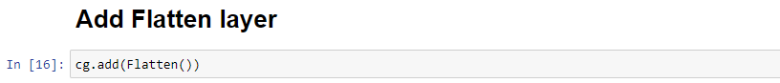

* **Adding Dense Layers**

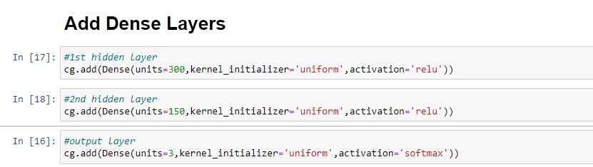

**Configuring the learning process:**



**Train the model**

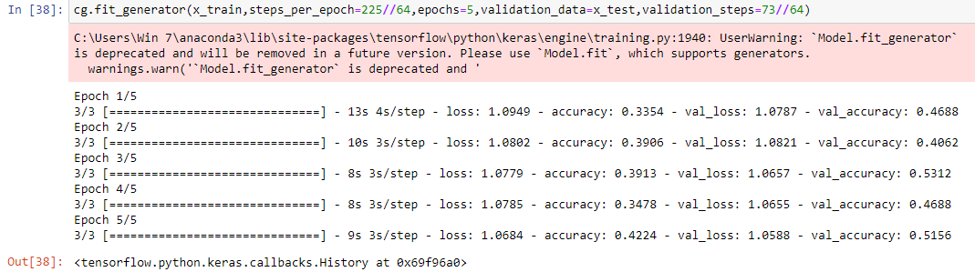

**Save the model**



**PREDICTION:**



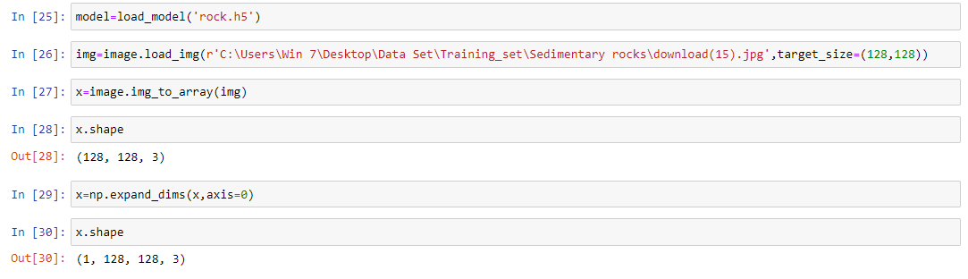

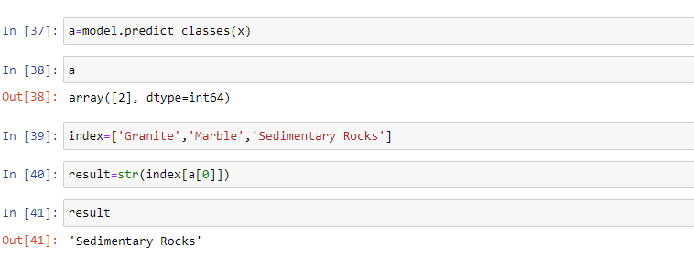

APPLICATION BUILDING

**Creating a HTML File , flask application**

● Build python code

● Importing Libraries

● Routing to the html Page

● Showcasing prediction on UI

● Run The app in local browser.

PROJECT STRUCTURE:

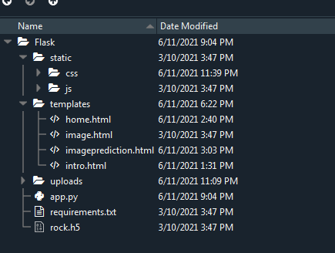

**STEPS 1: BUILDING AN INDEX**. **Html file**

This is the basic HTML page for our Project. Here we are creating two buttons one used to browse

pictures from local drive and other button is used to send this picture to the model file which

analyses the picture and show cases the prediction in the result. The browsed picture is displayed

on the html page using on image preview using main.js script. You can see the scripted file is called

in html page using src tag

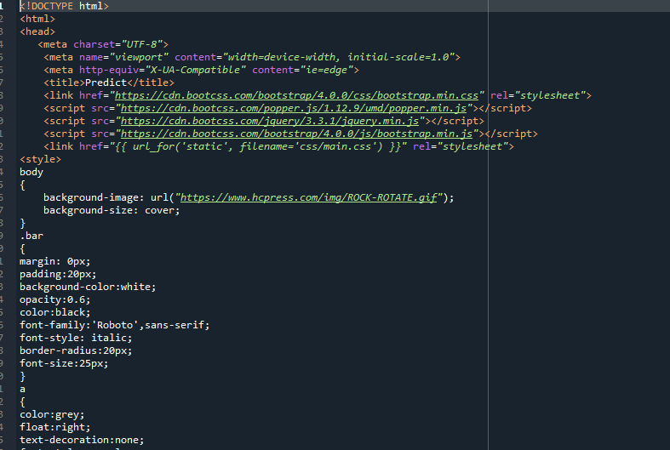

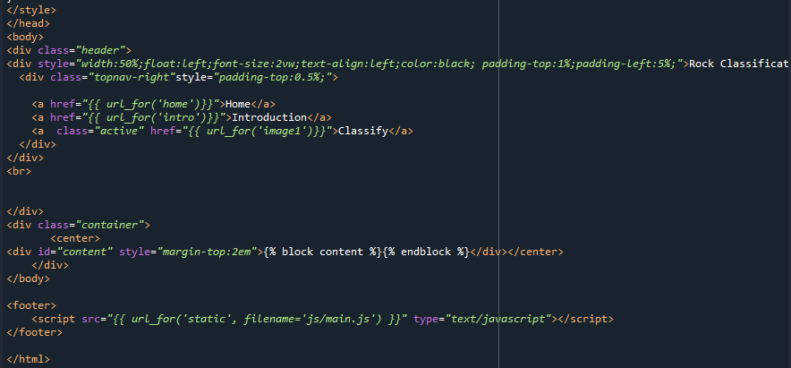

**The built html page looks like:**

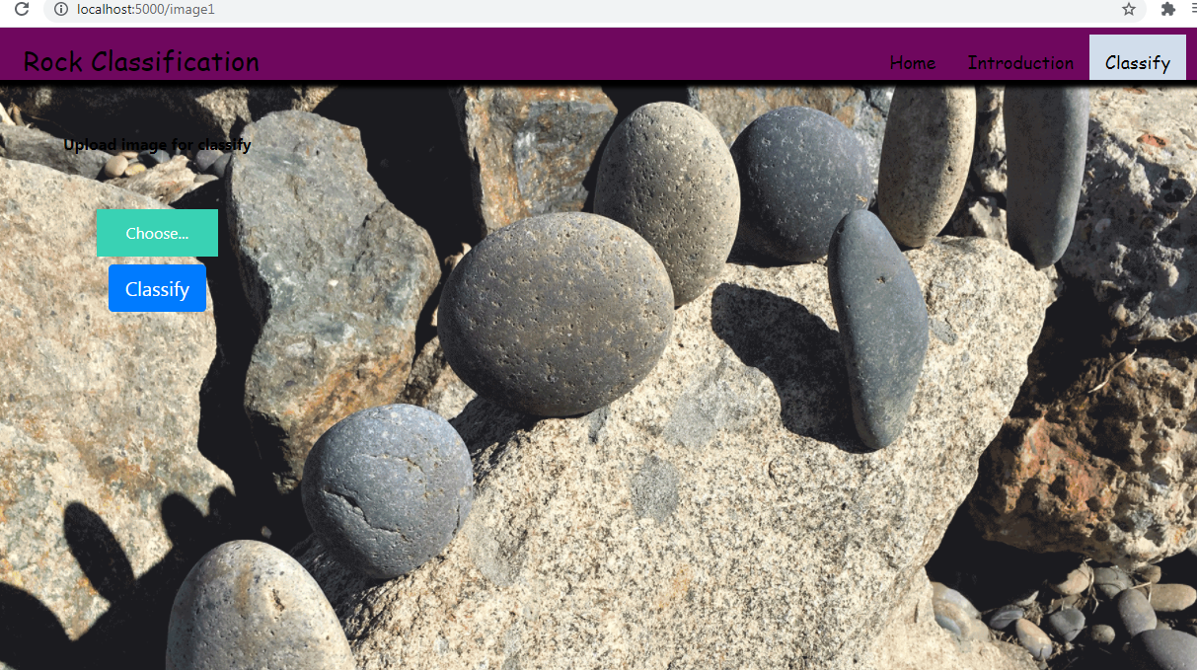

**STEP 2: BUILD PYTHON CODE**

We will be using python for server side scripting.

Let’s see step by step process for writing backend code. Importing Librariesϖ We are importing

the libraries for processing the uploaded picture Loading the built model, saving the browsed

pictures in uploads folder. And dependent library default graph for model prediction

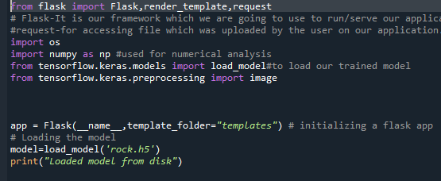

**ROUTING TO THE HTML PAGE**

Here we will be using declared constructor to route to the html page which we have created earlier.

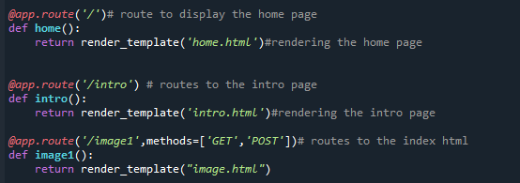

Whenever you browse an image from the html page this photo can be accesses through POST or GET Method.

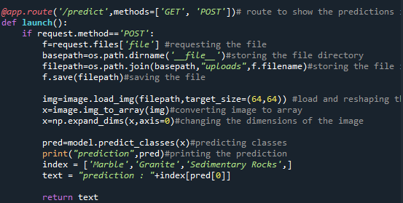

Here we are defining a function which request the browsed file from html page using post method. The requested picture file is then saved to the uploads folder in this same directory using OS library. Using load image class from Keras library we are retrieving the saved picture from the path declared. We are applying some image processing techniques and then sending that preprocessed image to the model for predicting the class. This returns the numerical value of a class (like 0,1 ,2 etc.) which lies in the 0th index of the variable preds. This numerical value is passed to the index variable declared. This returns the name of the class. This name is rendered to the predict variable used in html page.

**Main Function**

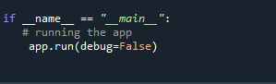

**Run the application:**

* Open anaconda prompt from start menu
* Navigate to the folder where your app.py resides
* Now type “python app.py” command
* It will show the local host where your app is running.
* Navigate to the localhost where you can view your web page
* Browse the image and click on predict function to see prediction.

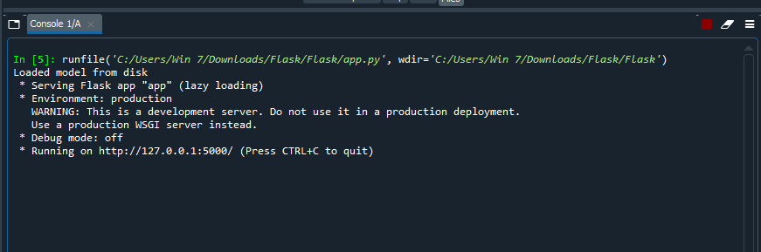

**OUTPUT SCREEN:**

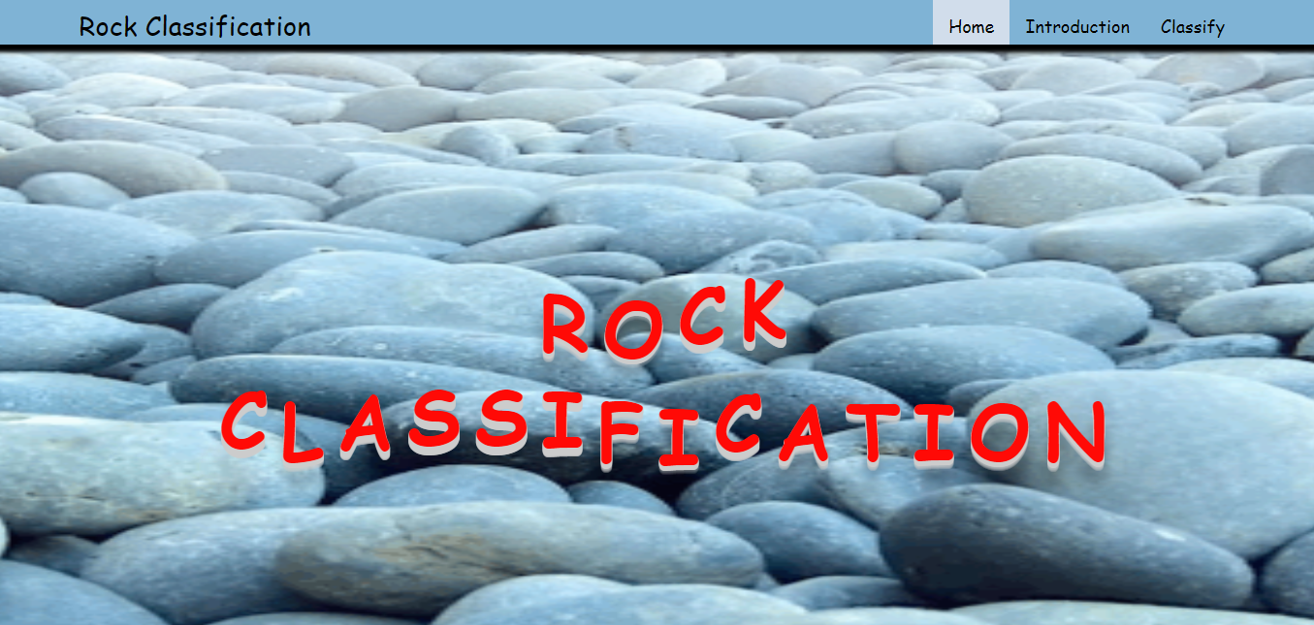

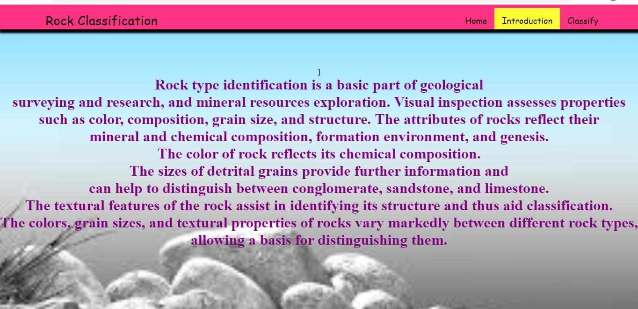

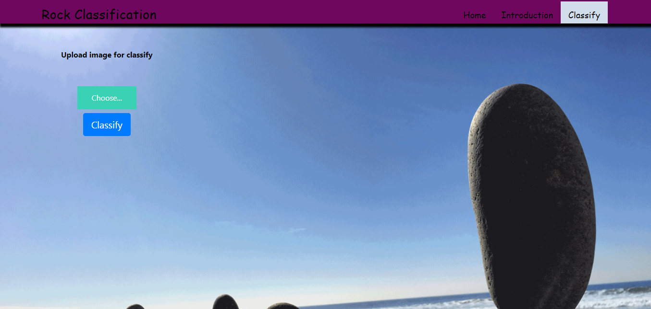

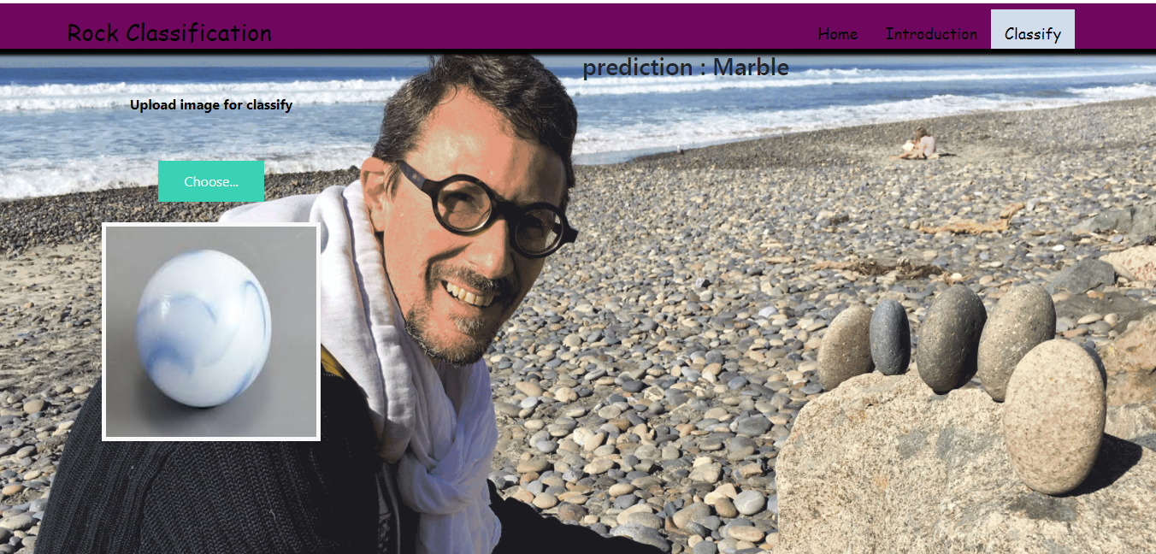

**ADVANTAGES:**

* Very High accuracy in image recognition problems.
* Automatically detects the important features without any human supervision.
* Weight sharing.

**DISADVANTAGES:**

* CNN do not encode the position and orientation of object.
* Lack of ability to be spatially invariant to the input data.
* Lots of training data is required.

**APPLICATIONS :**

### Decoding Facial Recognition

### Analyzing Documents

### **Understanding Climate**

1. Grey Areas

**FUTURE SCOPE:**

1. Facial Key point Detection.

2. Analysis of Satellite images for Disaster Detection.

3. Real Time Criminal Detection through video analysis.

4. One potential future application of CNN microprocessors is used to combine them with the DNA microarrays to allow for a near-real time DNA analysis of hundreds of thousands of different DNA sequences.

**CONCLUSION**

**CNN** is the best artificial neural network, it is used for modeling image but it is not limited to just modeling of the image but out of many of its applications. Convolutional Neural Networks uncover and describe the hidden data in an accessible manner. Even in its most basic applications, it is impressive how much is possible with the help of a neural network.

The way CNN recognizes images says a lot about the composition and execution of the visuals. But, Convolutional Neural Networks also discover newer drugs, which is one of the many inspiring examples of artificial neural networks making the world a better place. It teaches us how we perceive images and learn useful applications to classify images and videos.

After learning CNN, I realized that I could use this for my project at Google to detect phishing attacks. I also realized that the knowledge for CNN is very deep. Over the years, there are many improvements in CNN variations including one of the latest — ResNet — which even beats human reviewers in ImageNet classifications.

**REFERENCES:**

<https://ieeexplore.ieee.org/document/8964384?denied>=

<https://www.researchgate.net/publication/335239034_Rock_Classification_from_Field_Image_Patches_Analyzed_Using_a_Deep_Convolutional_Neural_Network>

<https://iopscience.iop.org/article/10.1088/1742-6596/887/1/012089>